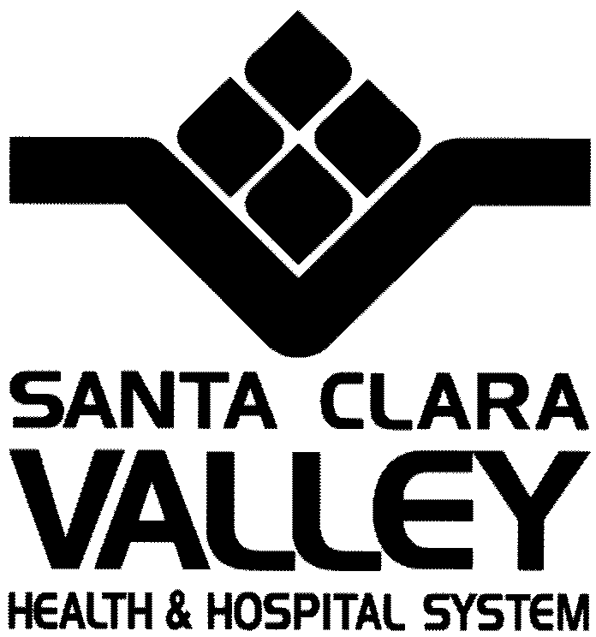

Mental Health Department

828 South Bascom Avenue, Suite 200

San José, California 95128

Tel (408) 885-5770

Dedicated to the Health Fax (408) 885-5788

Of the Whole Community Fax (408) 885-5789

D.2: Development Description

Project: Ford & Monterey Family Housing
Sponsors: Eden Housing, Inc.
Location: Ford & Monterey Roads, San Jose CA

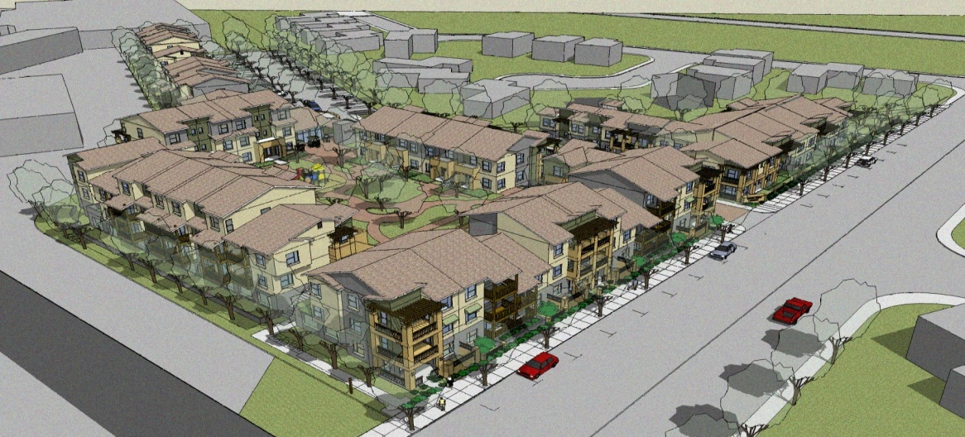

Project Summary
Ford & Monterey Family Housing is a new construction, 75-unit permanent affordable rental housing development by Eden Housing, Inc.

The Ford & Monterey development is located in South San Jose on a parcel of land owned by the City of San Jose. Eden was selected to develop this parcel in the Fall of 2008, and has fully entitled a 95 unit project to serve both low income families and individuals with special needs. Eden was able to secure financing from HUD’s 811 program to move forward on the special needs units, and the development will now be phased into two projects as follows: Phase 1: 20 units of special needs housing and Phase 2: 75-unit family rental development (the subject of this application)

Ford & Monterey Family Housing is targeted to very low and extremely low income families earning between 20% AMI and 50%AMI. Five (5) units will be set-aside for MHSA households earning less than 30% AMI with services to be provided by Santa Clara County. The proposed plan includes:
- 12 one bedrooms,
- 40 two bedrooms, and
- 33 three bedrooms.

These units are distributed across three buildings, with townhomes over flats.

The site is located south of the City’s Downtown, in the Silver Leaf neighborhood, an established neighborhood of single family homes with a medium-sized retail shopping complex and nearby parks and schools. The retail center is directly adjacent to the project site and includes a full scale grocery store, pharmacy, bank and big box retailer. These retail amenities will directly serve residents and their families and offer employment opportunities for future residents. Finally, the project offers convenient access to Monterey Road and Highway 101 and is within walking distance of the Cal-Train Blossom Hill Station on Monterey Road, and several VTA bus routes. These transit options will easily connect residents to major employment centers such as Downtown San Jose, San Jose City College, the San Jose International Airport and downtown San Francisco.

The majority of the development’s 121 parking spaces provided in a ground level parking structure that is wrapped with residential units to ensure a street-friendly and pedestrian-oriented presence in the surrounding community. On-site amenities include a community room and computer center, where Eden Housing Resident Services will provide programs for children, computer and education classes for families, and social activities for all residents. Landscaped grounds, including play areas for children, courtyards with barbecues, and central laundry facilities round out the planned on-site amenities for this community.

Housing and Service Goals and Tenants to be Served
The goal of this housing project will be to house, with supportive services, at least five (5) severely mentally ill individuals who are chronically homeless. All of the five MHSA-funded units will be designated for households with at least one tenant who has a severe mental illness. The MHSA units will be distributed one-bedroom units. It will be the aim of those providing services to these tenants that they will be able to remain in this permanent housing while accessing the services appropriate to their needs. Case Managers and Peer Mentors provided by the Santa Clara County Mental Health Department (MHD) or their designee will work with these individuals to enable them to enhance their independent living skills, obtain employment where possible, increase their money management skills, obtain support from other sources, participate in support groups and social/ recreational activities, and obtain other assistance as needed. Service coordinators provided by Eden Housing Resident Services, Inc. will also assist them in accessing services—as they will with the other residents in the development.

Type of Housing
Ford & Monterey Family Housing is permanent, affordable rental housing for households at or below 50% of Area Median Income (AMI) and offers one-bedroom, two-bedroom, and three-bedroom units.

Primary Service Provider
The MHD will be responsible for ensuring that services are provided to the MHSA residents. However, most likely there will be several service providers assigned to the care of the MHSA residents. In order to facilitate a coordinated service delivery approach, the responsible County service provider (i.e. Housing Support Liaison) will meet with representatives from the individual service providers involved and will coordinate the services that will be delivered on site. He/she will facilitate meetings with the Case Managers and others as needed to ensure appropriate service delivery. Thus, the Housing Support Liaison will serve as the single point of contact for communicating between service providers and property management staff and coordinating supportive services for the residents of the MHSA-funded units.

Development Partners
Eden Housing, Inc. is the sponsor of Ford & Monterey Family Housing. A to-be-named non-profit affiliate of Eden Housing, Inc. will be the co-General Partner of the final ownership entity. Eden Housing Inc. has 43 years of experience developing affordable rental housing having completed over 5,500 units in six Bay Area counties.

Development Financing
The table below illustrates the current construction and permanent financing plan.

CONSTRUCTION SOURCES
Construction Loan $17,355,862
Value of City Loan Donation $4,155,200
Santa Clara County Housing Authority Loan $6,500,000
Housing Trust Loan $500,000
Investor Capital Contributions $1,446,257
TOTAL CONSTRUCTION SOURCES $29,957,319

PERMANENT SOURCES
Conventional First Mortgage $3,322,056
Value of City Loan Donation $4,155,200
Special GP/ City Contribution $5,021,559
Santa Clara County Housing Authority Loan $6,500,000
Housing Trust Loan $500,000
AHP Loan $740,000
MHSA Loan $500,000
MHSA Capitalized Operating Subsidy $500,000
Investor Capital Contributions $10,329,627
Deferred Developer Fee $127,500
Sponsor or Borrower Equity $200,000
TOTAL PERMANENT SOURCES $31,895,941

