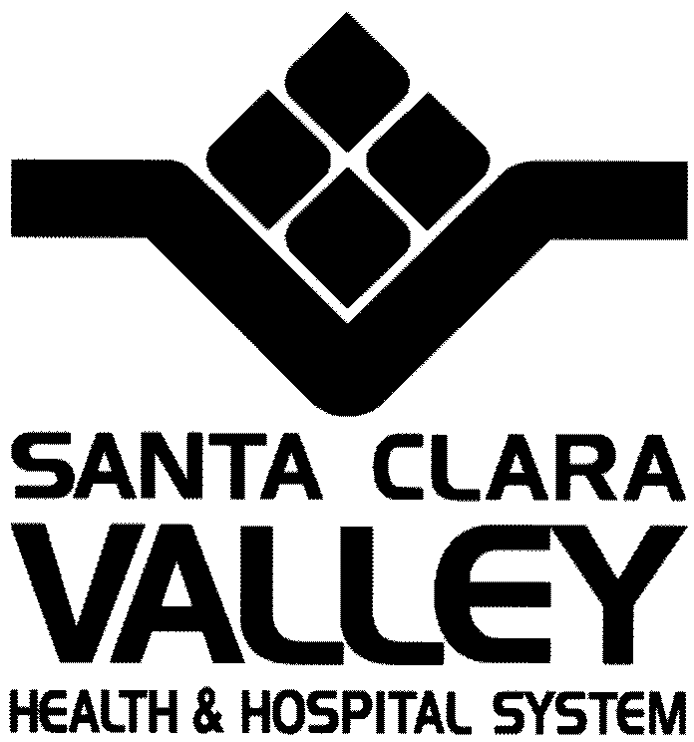

Mental Health Department

828 South Bascom Avenue, Suite 200

San José, California 95128

Tel (408) 885-5770

Dedicated to the Health Fax (408) 885-5788

Of the Whole Community Fax (408) 885-5789

Section D.9……Design Considerations for Meeting the Needs of the MHSA Housing Program Target Population

Armory Family Housing

MidPen Housing Corporation recognizes the importance of the built environment to our MHSA Target Population. As the developer, MidPen will collaborate with Jon Worden Architects to ensure design elements implement a secure, stable, calm, and pleasant environment for the well-being of our residents. Additionally, all standard ADA guidelines will be observed.

Due to the proximity of the project to the intersection of Fair Oaks and Maude Avenue, we will implement design options to reduce exterior traffic noise, through enhanced insulated walls and blinds over windows. Private units and common space will include plenty of windows ensuring ample natural sunlight.

MidPen will also employ state of the art Green Building Standards to ensure optimal indoor air quality for the residents. In fact, in MidPen’s most recent supportive housing project we achieved a Green Point Rating of 218, the highest of any project in the State of California since the rating system was established. At the Armory Family Housing project we will implement similar measures to enhance indoor air quality including low/no VOC paint and flooring materials and formaldehyde free wall insulation and cabinetry. In addition, the ventilation, heating and air circulation systems will decrease the risk and spread of toxic air pollutants. The units will be designed to maximize intake of fresh air and to promote the circulation of fresh air throughout the units and corridors.

The design of the units will strategically use color and lighting to provide a safe, secure and calm environment. Individual units will be designed to promote individual privacy and security.

On-site services will be coordinated by MidPen Services Corporation who will provide on-site staffing at the complex on a full time basis. This will help facilitate communication between MidPen Property Management and the Santa Clara County Mental Health Department who will be the designated primary service provider providing case management services for the MHSA residents. Case Managers will visit the tenants on a regular basis and attend to their needs appropriately. In this environment, the Case Managers will also organize and coordinate—while working with the housing staff on site—helpful workshops, support groups, and social/recreational activities.

Although the County Mental Health Department will be the lead service provider for the MHSA residents, any service provider that participates in the MHD’s System of Care and that serves the target population can refer a prospective tenant to this housing program and provide services to him/ her while he/she is a tenant in any of the housing sites designated in this application. Whether the prospective resident is referred by a Case Manager from a county mental health clinic or another mental health service provider, he/she will receive the personalized attention that they need and deserve during the time that he/she is housed. This individualized attention provided with the service philosophy mentioned previously will enable the individual to remain in his/her housing, even if he/she decompensates and needs to be hospitalized or enter a recovery program. Finally, the staff involved in the resident’s care will meet on a regular basis to integrate their work with the resident and chart his/her progress according to his/her individualized Wellness Recovery Action Plan.

In addition, mental health counseling and medication assistance will be made available to the tenants through their usual appointments with their psychiatrists and medical professionals at mental health and medical clinics. The tenants will be able to access those and other off-site services through the help of their Case Manager, family/friends, public transportation, or Outreach, a non-profit paratransit provider.

The County will also provide a Housing Support Liaison to facilitate interactions between MHSA tenants, their Case Managers, and property management.

At least one office (150 sq. ft.) will be dedicated on site for use by the support services staff to provide confidential counseling.

Finally, this affordable housing complex for very low income families is ideally situated in the City of Sunnyvale and is near to important services and amenities for families including Fair Oaks Park and the Columbia Neighborhood Center at Columbia Middle School which provides important “wrap around” services for extremely low income families with children.

