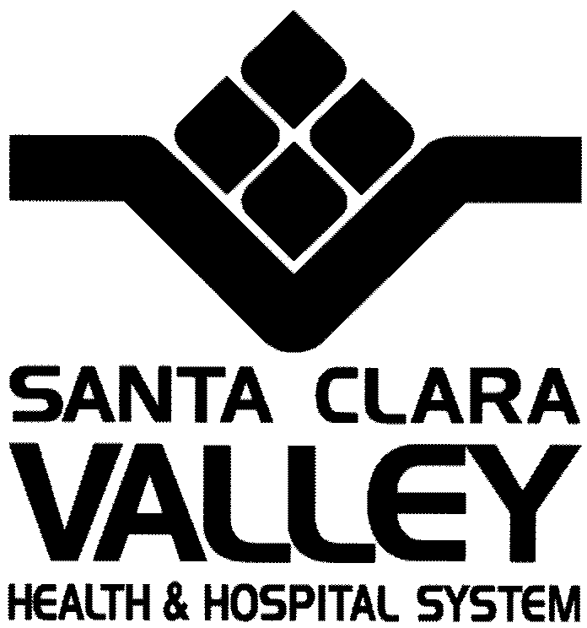

## Mental Health Department

## 828 South Bascom Avenue, Suite 200

## San José, California 95128

## Tel (408) 885-5770

## *Dedicated to the Health* Fax (408) 885-5788

## *Of the Whole Community* Fax (408) 885-5789

### Section D.2.……Development Description



### Project Summary

The Amory Family Housing is a new construction project being developed by MidPen Housing that will include 60 units of permanent, affordable rental housing for families at or below 50% of Area Median Income (AMI). Fourteen of these units will be reserved for households with mentally ill members at or below 50% AMI who are chronically homeless. The tenant portion of the rent for these units will be the equivalent of 30% of a household’s SSI income. This project provides a community meeting room and kitchen, computer lab, laundry, common restrooms, and outdoor courtyards with play space and area for community gardens. This project is located at 620 E. Maude Avenue in Sunnyvale.

MidPen Housing (“MidPen”) is the project sponsor. The project’s property management agent (“Management Agent”) and service coordinator (“Service Coordinator”) will be provided by MidPen wholly owned subsidiaries.

**Overall Site Concept**

The site, currently occupied by a National Guard Armory building and an adjacent paved parking area, is bounded by East Maude and North Wolfe on the north and east and the yards of residential parcels and a church on the south and west. It is located directly across from Fair Oaks Park and within walking distance of transit, shopping, schools and employment.

The proposed development divides the site into two adjacent and abutting projects separated by a ground lease line. MidPen Housing will develop the western rectangular portion as low-income family apartments. Charities Housing will develop the triangular eastern portion as low income, single room occupancy apartments. The two projects have been planned collaboratively, but each will be developed, constructed and operated independently. While we anticipate that they will be entitled together, construction documentation and permitting will be two separate processes.

**Overall Building Concept**

Both MidPen and Charities projects consist of stacked flats surrounding podium level courtyards over an on grade concrete garage. Special care has been taken to ensure that the public frontage of each project’s garage is lined with active uses. Each project has an independent circulation, stair, elevator and exiting system. Each project’s garage is an independent structure. The garage podiums are planned to be the same height so that podium level landscape spaces while separate will be visually contiguous.

**Family Apartment Project**

The MidPen family project consists of 60 stacked flat apartments over an on-grade concrete garage containing 110 spaces. The parking ratio is 1:1 for the one-bedroom apartments and 2:1 for the two and three bedroom apartments. The garage is open and naturally ventilated along the west and south, abuts the Charities garage on the east and is faced with on-grade apartments and the project entry lobby and offices along East Maude. The garage also contains a secure bicycle storage room and a refuse and recycling room fed by chutes adjacent to each floors elevator lobby. Primary access to the garage is via a two-way driveway off East Maude Street as well as through the Charities garage from North Wolfe Road.

The project elevator and lobby stair are located in the three level building and (in addition to serving each of the apartments) connect the street level entry lobby and offices with a series of podium level community spaces overlooking the central courtyard. A common laundry is located at the inside corner of the “L” shaped building. A fitness center is in the same location on the upper level. In addition to perimeter raised bed planters tied into the project’s storm water management system, the central courtyard is programmatically divided into three distinct outdoor rooms: A common gathering space with bar-b-que and picnic tables, a children’s play area with a play structure and a common garden area with raised bed planters.

The project’s 60 apartments are a mix of 20-3 bedroom, 20-2 bedroom and 20-1 bedroom apartments. Each apartment has a private outdoor space, either deck or patio, with a minimum depth of 6 feet and a minimum area of 60 square feet. All apartments are adaptable. We anticipate the R-2 residential portion of the project to be Type V-A, fully sprinklered/ NFPA-13.

**Housing and Service Goals and Tenants to be Served**

The goal of this housing project will be to provide housing with supportive services to ten (10) mentally ill households who are chronically homeless. These units will be designated for MHSA tenants. Service providers will be able to furnish appropriate tenant services on-site. County-provided Case Managers will work with these individuals to enable them to enhance their independent living skills, obtain employment, increase their money management skills, obtain support from other sources (including in-home support if needed), take part in support group and social/recreational activities, and obtain other assistance as needed. Tenant participa­tion in these activities will be voluntary. Case Managers and Service Coordinators will also help tenants obtain additional services, including services available to other residents in the community.

### Type of Housing

Armory Family Housing is permanent, affordable rental housing for households at or below 50% of Area Median Income (AMI) and offers a mix of one, two and three-bedroom units.

### Way that the Housing Will Meet the Housing and Service Needs of the Tenants

Case Managers will visit the tenants on a regular basis and attend to their needs appropriately. In this environment, the Case Managers will also organize and coordinate—while working with the housing staff on site—helpful workshops, support groups, and social/recreational activities.

In addition, mental health counseling and medication assistance will be made available to the tenants through their usual appointments with their psychiatrists and medical professionals at mental health and medical clinics. The tenants will be able to access those and other off-site services through the help of their Case Manager, family/friends, public transportation, or Outreach, a non-profit paratransit provider.

The County will also provide a Housing Support Liaison to facilitate interactions between MHSA tenants, their Case Managers, and property management.

### Primary Service Provider

The Santa Clara County Mental Health Department is designated as the primary service provider.

However, any service provider that participates in the MHD’s System of Care and that serves the adult population can refer a consumer to this housing program and provide services to him/ her while he/she is a tenant in any of the housing sites designated in this application. Whether the consumer is referred by a Case Manager from a county mental health clinic or another mental health service provider, he/she will receive the personalized attention that they need and deserve during the time that he/she is housed. This individualized attention provided with the service philosophy mentioned previously will enable the individual to remain in his/her housing, even if he/she decom­pensates and needs to be hospitalized or enter a recovery program. Finally, the staff involved in the consumer’s care will meet on a regular basis to integrate their work with the consumer and chart his/her progress according to his/her individualized Wellness Recovery Action Plan.

### Development Financing

The total development sources for this project are approximately $27,296,455. This represents funds from expected tax credit equity for Federal credits, funds from the Federal Home Loan Bank’s Affordable Housing Program (AHP), a loan from the City of Sunnyvale, a loan from the Santa Clara Housing Trust, and a conventional mortgage loan, along with financing from the MHSA program in the form of a capital contribution and a COSR reserve.

Permanent sources are listed in the table below.

**PERMANENT SOURCES $469,662./unit.**

City of Sunnyvale—Ground Lease $3,700,000.

City of Sunnyvale $1,700,000.

Deferred Developer Fee $200,000.

Permanent Loan $763,655.

Tax Credit Equity $19,183,294.

AHP $500,000.

County CDBG/HOME $444,380.

MHSA Capital $750,000.

State HCD 116 $938,320.

**TOTAL $28,179,650.**